***4. METHOD DESIGN***

**4.1 Entity**

**4.1.1 MD-01: User**

**Class Name: User**

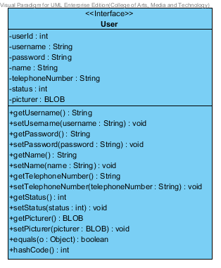

**Entities**

|  |  |  |  |
| --- | --- | --- | --- |
| **ID** | **NAME** | **DESCRIPTION** | **REMARK** |
| 1 | userId | This is an id for identify the object of User Class. | **TYPE :** Integer |
| 2 | username | This is a username of user. | **TYPE :** String |
| 3 | password | This is a password of user. | **TYPE :** String |
| 4 | name | This is a Full-name of user. | **TYPE :** String |
| 5 | telephoneNumber | This is a telephone number of user. | **TYPE :** String |
| 6 | status | This is a status to separate the type of User Object. | **TYPE :** Integer |
| 7 | Picture | This is a picture of user. | **TYPE :** BLOB |

|  |  |  |  |
| --- | --- | --- | --- |
| **ID** | **NAME** | **DESCRIPTION** | **REMARK** |
| 1 | equals() |  | **Return Type :** Boolean  **Parameters :** Object |
| 2 | hashCode() |  | **Return Type :** Integer |

**Method**

**4.1.2 MD-02: Administrator**

**Class Name: Administrator**

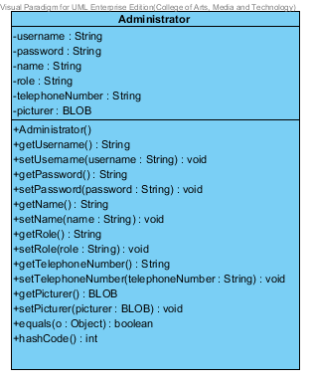

**Entities**

|  |  |  |  |
| --- | --- | --- | --- |
| **ID** | **NAME** | **DESCRIPTION** | **REMARK** |
| 1 | username | This is a username of Administrator. | **TYPE :** String |
| 2 | password | This is a password of Administrator. | **TYPE :** String |
| 3 | name | This is a Full-name of Administrator. | **TYPE :** String |
| 4 | role | This is a role that Administrator responsibility. | **TYPE :** String |
| 5 | telephoneNumber | This is a telephone number of Administrator. | **TYPE :** String |
| 6 | Picture | This is a picture of Administrator. | **TYPE :** BLOB |

|  |  |  |  |
| --- | --- | --- | --- |
| **ID** | **NAME** | **DESCRIPTION** | **REMARK** |
| 1 | equals() |  | **Return Type :** Boolean  **Parameters :** Object |
| 2 | hashCode() |  | **Return Type :** Integer |

**Method**

**4.1.3 MD-03: Customer**

**Class Name: Customer**

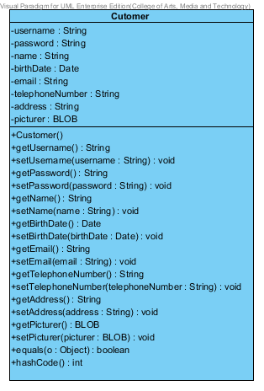

**Entities**

|  |  |  |  |
| --- | --- | --- | --- |
| **ID** | **NAME** | **DESCRIPTION** | **REMARK** |
| 1 | username | This is a username of customer. | **TYPE :** String |
| 2 | password | This is a password of customer. | **TYPE :** String |
| 3 | name | This is a Full-name of customer. | **TYPE :** String |
| 4 | birthDate | This is a birth date of customer | **TYPE :** String |
| 5 | email | This is an email of customer. | **TYPE :** String |
| 6 | telephoneNumber | This is a telephone number of customer. | **TYPE :** String |
| 7 | address | This is an address of customer. | **TYPE :** String |
| 8 | Picture | This is a picture of customer. | **TYPE :** BLOB |

|  |  |  |  |
| --- | --- | --- | --- |
| **ID** | **NAME** | **DESCRIPTION** | **REMARK** |
| 1 | equals() |  | **Return Type :** Boolean  **Parameters :** Object |
| 2 | hashCode() |  | **Return Type :** Integer |

**Method**

**4.1.4 MD-04: Product**

**Class Name: Product**

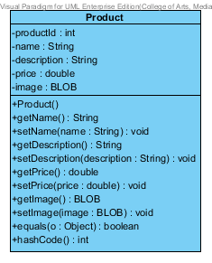

**Entities**

|  |  |  |  |
| --- | --- | --- | --- |
| **ID** | **NAME** | **DESCRIPTION** | **REMARK** |
| 1 | productId | This is an id for identify the object of Product Class. | **TYPE :** Integer |
| 2 | Name | This is a name of product. | **TYPE :** String |
| 3 | description | This is a description of product. | **TYPE :** String |
| 4 | Price | This is a price of product | **TYPE :** Double |
| 5 | Image | This is an image of product. | **TYPE :** BLOB |

|  |  |  |  |
| --- | --- | --- | --- |
| **ID** | **NAME** | **DESCRIPTION** | **REMARK** |
| 1 | equals() |  | **Return Type :** Boolean  **Parameters :** Object |
| 2 | hashCode() |  | **Return Type :** Integer |

**Method**

**4.1.5 MD-05: Shopping Cart**

**Class Name: Shopping Cart**

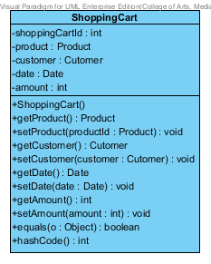

**Entities**

|  |  |  |  |
| --- | --- | --- | --- |
| **ID** | **NAME** | **DESCRIPTION** | **REMARK** |
| 1 | shoppingCartId | This is an id for identify the object of shopping Cart Class. | **TYPE :** Integer |
| 2 | product | This is an object to hold product information. | **TYPE :** Product |
| 3 | customer | This is an object to hold customer information. | **TYPE :** Customer |
| 4 | date | This is a date when customer is adding a product into The shopping Cart. | **TYPE :** Date |
| 5 | amount | This is an amount of product which is customer adding into the shopping Cart. | **TYPE :** Integer |

|  |  |  |  |
| --- | --- | --- | --- |
| **ID** | **NAME** | **DESCRIPTION** | **REMARK** |
| 1 | equals() |  | **Return Type :** Boolean  **Parameters :** Object |
| 2 | hashCode() |  | **Return Type :** Integer |

**Method**

**4.1.6 MD-06: History**

**Class Name: History**

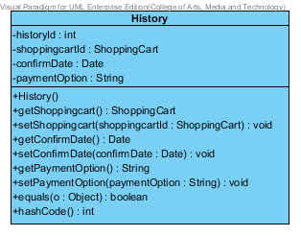

**Entities**

|  |  |  |  |
| --- | --- | --- | --- |
| **ID** | **NAME** | **DESCRIPTION** | **REMARK** |
| 1 | historyId | This is an id for identify the object of History Class. | **TYPE :** Integer |
| 2 | shoppingCartId | This is an object to hold shopping Cart information. | **TYPE :** ShoppingCart |
| 3 | confirmDate | This is a date when customer confirm to purchase a product. | **TYPE :** Date |
| 4 | paymentOption | This is a payment Option which consist of transfer, credit card and Paypal. | **TYPE :** String |

|  |  |  |  |
| --- | --- | --- | --- |
| **ID** | **NAME** | **DESCRIPTION** | **REMARK** |
| 1 | equals() |  | **Return Type :** Boolean |
| 2 | hashCode() |  | **Return Type :** Integer |

**Method**

**4.2 MVC Pattern of User Class**

**4.2.1 MD-07: UserDAO**

**Class Name: UserDAO**

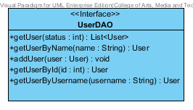

|  |  |  |  |
| --- | --- | --- | --- |
| **ID** | **NAME** | **DESCRIPTION** | **REMARK** |
| 1 | getUser() | This method uses for getting a user. | **Return Type :** List<User>  **Parameters :** status |
| 2 | getUserByName() | This method uses for getting a user by using user’s name from database. | **Return Type :** User  **Parameters :** name |
| 3 | addUser() | This method uses for adding a user into a database. | **Return Type :** void  **Parameters :** user |
| 4 | getUserById() | This method uses for getting a user by using user’s id from database. | **Return Type :** User  **Parameters :** id |
| 5 | getUserByUsername() | This method uses for getting a user by using user’s username from database. | **Return Type :** User  **Parameters :** username |

**Method**

**4.2.2 MD-08: UserDAOImpl**

**Class Name: UserDAOImpl**

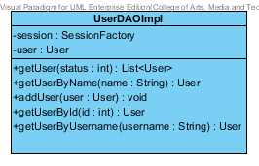

**Entities**

|  |  |  |  |
| --- | --- | --- | --- |
| **ID** | **NAME** | **DESCRIPTION** | **REMARK** |
| 1 | session | This is an object to hold sessionFactory. | **TYPE :** SessionFactory |
| 2 | user | This is an object to hold user’s information. | **TYPE :** User |

**Method**

|  |  |  |  |
| --- | --- | --- | --- |
| **ID** | **NAME** | **DESCRIPTION** | **REMARK** |
| 1 | getUser() | This method uses for getting a user. | **Return Type :** List<User>  **Parameters :** status |
| 2 | getUserByName() | This method uses for getting a user by using user’s name from database. | **Return Type :** User  **Parameters :** name |
| 3 | addUser() | This method uses for adding a user into a database. | **Return Type :** void  **Parameters :** user |
| 4 | getUserById() | This method uses for getting a user by using user’s id from database. | **Return Type :** User  **Parameters :** id |
| 5 | getUserByUsername() | This method uses for getting a user by using user’s username from database. | **Return Type :** User  **Parameters :** username |

**4.2.3 MD-09: UserService**

**Class Name: UserService**

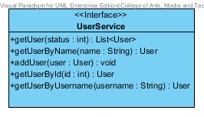

**Method**

|  |  |  |  |
| --- | --- | --- | --- |
| **ID** | **NAME** | **DESCRIPTION** | **REMARK** |
| 1 | getUser() | This method uses for getting a user. | **Return Type :** List<User>  **Parameters :** status |
| 2 | getUserByName() | This method uses for getting a user by using user’s name from database. | **Return Type :** User  **Parameters :** name |
| 3 | addUser() | This method uses for adding a user into a database. | **Return Type :** void  **Parameters :** user |
| 4 | getUserById() | This method uses for getting a user by using user’s id from database. | **Return Type :** User  **Parameters :** id |
| 5 | getUserByUsername() | This method uses for getting a user by using user’s username from database. | **Return Type :** User  **Parameters :** username |

**4.2.4 MD-10: UserServiceImpl**

**Class Name: UserServiceImpl**

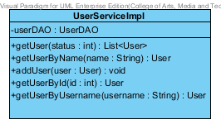

**Entities**

|  |  |  |  |
| --- | --- | --- | --- |
| **ID** | **NAME** | **DESCRIPTION** | **REMARK** |
| 1 | userDAO | This is an object to hold userDAO Class. | **TYPE :** UserDAO |

**Method**

|  |  |  |  |
| --- | --- | --- | --- |
| **ID** | **NAME** | **DESCRIPTION** | **REMARK** |
| 1 | getUser() | This method uses for getting a user. | **Return Type :** List<User>  **Parameters :** status |
| 2 | getUserByName() | This method uses for getting a user by using user’s name from database. | **Return Type :** User  **Parameters :** name |
| 3 | addUser() | This method uses for adding a user into a database. | **Return Type :** void  **Parameters :** user |
| 4 | getUserById() | This method uses for getting a user by using user’s id from database. | **Return Type :** User  **Parameters :** id |
| 5 | getUserByUsername() | This method uses for getting a user by using user’s username from database. | **Return Type :** User  **Parameters :** username |

**4.2.5 MD-11: UserController**

**Class Name: UserController**

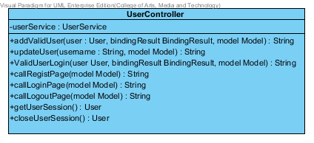

**Entities**

|  |  |  |  |
| --- | --- | --- | --- |
| **ID** | **NAME** | **DESCRIPTION** | **REMARK** |
| 1 | userService | This is an object to hold userService Class. | **TYPE :** UserService |

**Method**

|  |  |  |  |
| --- | --- | --- | --- |
| **ID** | **NAME** | **DESCRIPTION** | **REMARK** |
| 1 | addValidUser() | This method uses for adding a valid user into database. | **Return Type :** String  **Parameters :** user, bindingResult, model |
| 2 | updateUser() | This method uses for update a user into a database. | **Return Type :** String  **Parameters :** username, model |
| 3 | validUserLogin() | This method uses for validate a user when user is login. | **Return Type :** String  **Parameters :** user, bindingResult, model |
| 4 | callRegistPage() | This method uses for connecting with Register Page . | **Return Type :** String  **Parameters :** model |
| 5 | callLoginPage() | This method uses for connecting with Login Page . | **Return Type :** String  **Parameters :** model |
| 6 | callLogoutPage() | This method uses for connecting with Logout Page. | **Return Type :** String  **Parameters :** model |
| 7 | getUserSession() | This method uses to get a user’s session. | **Return Type :** User |
| 8 | closeUserSession() | This method uses to close a user’s session. | **Return Type :** User |

**4.3 MVC Pattern of Product Class**

**4.3.1 MD-12: ProductDAO**

**Class Name: ProductDAO**

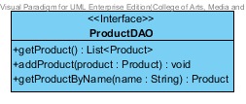

|  |  |  |  |
| --- | --- | --- | --- |
| **ID** | **NAME** | **DESCRIPTION** | **REMARK** |
| 1 | getProduct() | This method uses for getting a product. | **Return Type :** List<Product> |
| 2 | addProduct() | This method uses for adding a product into a database. | **Return Type :** void  **Parameters :** product |
| 3 | getProductByName() | This method uses for getting a product by using product’s name from database. | **Return Type :** User  **Parameters :** name |

**Method**

**4.3.2 MD-13: ProductDAOImpl**

**Class Name: ProductDAOImpl**

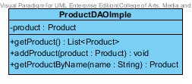

**Entities**

|  |  |  |  |
| --- | --- | --- | --- |
| **ID** | **NAME** | **DESCRIPTION** | **REMARK** |
| 1 | product | This is an object to hold product’s information. | **TYPE :** Product |

**Method**

|  |  |  |  |
| --- | --- | --- | --- |
| **ID** | **NAME** | **DESCRIPTION** | **REMARK** |
| 1 | getProduct() | This method uses for getting a product. | **Return Type :** List<Product> |
| 2 | addProduct() | This method uses for adding a product into a database. | **Return Type :** void  **Parameters :** product |
| 3 | getProductByName() | This method uses for getting a product by using product’s name from database. | **Return Type :** User  **Parameters :** name |

**4.3.3 MD-14: ProductService**

**Class Name: ProductService**

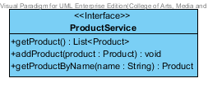

**Method**

|  |  |  |  |
| --- | --- | --- | --- |
| **ID** | **NAME** | **DESCRIPTION** | **REMARK** |
| 1 | getProduct() | This method uses for getting a product. | **Return Type :** List<Product> |
| 2 | addProduct() | This method uses for adding a product into a database. | **Return Type :** void  **Parameters :** product |
| 3 | getProductByName() | This method uses for getting a product by using product’s name from database. | **Return Type :** User  **Parameters :** name |

**4.3.4 MD-15: ProductServiceImpl**

**Class Name: ProductServiceImpl**

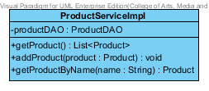

**Entities**

|  |  |  |  |
| --- | --- | --- | --- |
| **ID** | **NAME** | **DESCRIPTION** | **REMARK** |
| 1 | productDAO | This is an object to hold ProductDAO Class. | **TYPE :** ProductDAO |

**Method**

|  |  |  |  |
| --- | --- | --- | --- |
| **ID** | **NAME** | **DESCRIPTION** | **REMARK** |
| 1 | getProduct() | This method uses for getting a product. | **Return Type :** List<Product> |
| 2 | addProduct() | This method uses for adding a product into a database. | **Return Type :** void  **Parameters :** product |
| 3 | getProductByName() | This method uses for getting a product by using product’s name from database. | **Return Type :** User  **Parameters :** name |

**4.3.5 MD-16: ProductController**

**Class Name: ProductController**

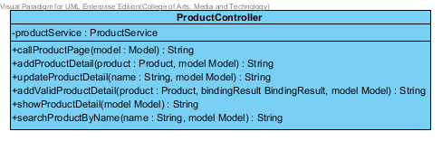

**Entities**

|  |  |  |  |
| --- | --- | --- | --- |
| **ID** | **NAME** | **DESCRIPTION** | **REMARK** |
| 1 | productService | This is an object to hold Product Service Class. | **TYPE :** ProductService |

**Method**

|  |  |  |  |
| --- | --- | --- | --- |
| **ID** | **NAME** | **DESCRIPTION** | **REMARK** |
| 1 | callProductPage() | This method uses for connecting with Product Page. | **Return Type :** String  **Parameters :** model |
| 2 | addProductDetail() | This method uses for adding a product detail into a database. | **Return Type :** String  **Parameters :** product, model |
| 3 | updateProductDetail() | This method uses for update a product when user is login. | **Return Type :** String  **Parameters :** name, model |
| 4 | addValidProductDetail() | This method uses for adding a valid product into database. | **Return Type :** String  **Parameters :** product, bindingResult, model |
| 5 | showProductDetail() | This method uses for showing a product detail into Product Page. | **Return Type :** String  **Parameters :** model |
| 6 | searchProductByName() | This method uses for searching a product by using product’s name from database. | **Return Type :** String  **Parameters :** name, model |

**4.4 MVC Pattern of ShoppingCart Class**

**4.4.1 MD-17: ShoppingCartDAO**

**Class Name: ShoppingCartDAO**

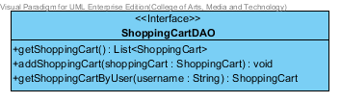

|  |  |  |  |
| --- | --- | --- | --- |
| **ID** | **NAME** | **DESCRIPTION** | **REMARK** |
| 1 | getShoppingCart () | This method uses for getting a Shopping Cart. | **Return Type :** -  **Parameters :** List<ShoppingCart> |
| 2 | addShoppingCart () | This method uses for adding a shopping cart by using shoppingCart. | **Return Type :** void  **Parameters :**shoppingCart |
| 3 | getShoppingCartByUser() | This method uses for getting a ShoppingCart by username. | **Return Type :** ShoppingCart  **Parameters :** username |

**4.4.2 MD-18: ShoppingCartDAOImpl**

**Class Name: ShoppingCartDAOImpl**

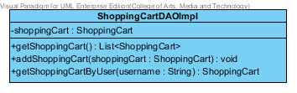

**Entities**

|  |  |  |  |
| --- | --- | --- | --- |
| **ID** | **NAME** | **DESCRIPTION** | **REMARK** |
| 1 | shoppingCart | This is an object to hold ShoppingCart. | **TYPE :** ShoppingCart |

**Method**

|  |  |  |  |
| --- | --- | --- | --- |
| **ID** | **NAME** | **DESCRIPTION** | **REMARK** |
| 1 | getShoppingCart () | This method uses for getting a ShoppingCart. | **Return Type :** List< ShoppingCart >  **Parameters :** status |
| 2 | addShoppingCart() | This method uses for adding ShoppingCart into database. | **Return Type :** Void  **Parameters :** ShoppingCart |
| 3 | getShoppingCartByUser() | This method uses for getting a ShoppingCart by username from a database. | **Return Type :** ShoppingCart  **Parameters :** username |

**4.4.3 MD-19: ShoppingCartService**

**Class Name: ShoppingCartService**

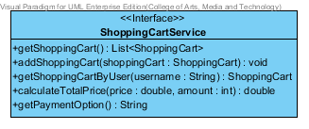

**Method**

|  |  |  |  |
| --- | --- | --- | --- |
| **ID** | **NAME** | **DESCRIPTION** | **REMARK** |
| 1 | getShoppingCart () | This method uses for getting a Shopping Cart. | **Return Type :** List<ShoppingCart>  **Parameters :** status |
| 2 | addShoppingCart () | This method uses for adding a shoppingCart in to a database. | **Return Type :** void  **Parameters :** name |
| 3 | getShoppingCart () | This method uses for adding a user into a database. | **Return Type :** ShoppingCart  **Parameters :** username |
| 4 | calculateTotalPrice() | This method uses for calculate the total price by using a price and amount. | **Return Type :** double  **Parameters :** price, amount |
| 5 | getPaymentOption() | This method uses for getting a payment option detail. | **Return Type :** String  **Parameters :** - |

**4.4.4 MD-20: ShoppingCartServiceImpl**

**Class Name: ShoppingCartServiceImpl**

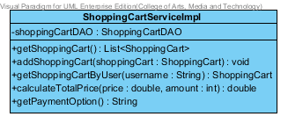

**Entities**

|  |  |  |  |
| --- | --- | --- | --- |
| **ID** | **NAME** | **DESCRIPTION** | **REMARK** |
| 1 | shoppingCartDAO | This is an object to hold shoppingCartDAO Class. | **TYPE :** shoppingCartDAO |

**Method**

|  |  |  |  |
| --- | --- | --- | --- |
| **ID** | **NAME** | **DESCRIPTION** | **REMARK** |
| 1 | getShoppingCart () | This method uses for getting a Shopping Cart. | **Return Type :** List<ShoppingCart>  **Parameters :** status |
| 2 | addShoppingCart () | This method uses for adding a shoppingCart in to a database. | **Return Type :** void  **Parameters :** name |
| 3 | getShoppingCart () | This method uses for adding a user into a database. | **Return Type :** ShoppingCart  **Parameters :** username |
| 4 | calculateTotalPrice() | This method uses for calculate the total price by using a price and amount. | **Return Type :** double  **Parameters :** price, amount |
| 5 | getPaymentOption() | This method uses for getting a payment option detail. | **Return Type :** String  **Parameters :** - |

**4.4.5 MD-21: ShoppingCartController**

**Class Name: ShoppingCartController**

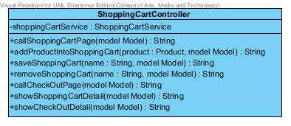

**Entities**

|  |  |  |  |
| --- | --- | --- | --- |
| **ID** | **NAME** | **DESCRIPTION** | **REMARK** |
| 1 | shoppingCartService | This is an object to hold shoppingCartService Class. | **TYPE :** ShoppingCartService |

**Method**

|  |  |  |  |
| --- | --- | --- | --- |
| **ID** | **NAME** | **DESCRIPTION** | **REMARK** |
| 1 | callShoppingCartPage() | This method uses for connecting with shoppingCart page from ShoppingCartUI. | **Return Type :** String  **Parameters :** model |
| 2 | addProductIntoShoppingCart() | This method uses for adding product into a database. | **Return Type :** String  **Parameters :** product, model |
| 3 | saveShoppingCart () | This method uses for adding shoppingCart by using name into database. | **Return Type :** String  **Parameters :** name, model |
| 4 | removeShoppingCart() | This method uses for delete shoppingCart by using name from database. | **Return Type :** String  **Parameters :** name, model |
| 5 | callCheckOutPage() | This method uses for connecting with check Out Page. | **Return Type :** String  **Parameters :** model |
| 6 | showShoppingCartDetail () | This method uses for showing with shopping Cart Page. | **Return Type :** String  **Parameters :** model |
| 7 | showCheckOutDetai() | This method uses for showing with check out page | **Return Type :** String  **Parameters :** model |

**4.5 MVC Pattern of History Class**

**4.5.1 MD-22: HistoryDAO**

**Class Name: HistoryDAO**

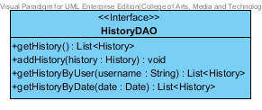

|  |  |  |  |
| --- | --- | --- | --- |
| **ID** | **NAME** | **DESCRIPTION** | **REMARK** |
| 1 | getHistory() | This method uses for getting a history. | **Return Type :** List<History> |
| 2 | addHistory() | This method uses for adding a history into a database. | **Return Type :** void  **Parameters :** history |
| 3 | getHistoryByName() | This method uses for getting a history list by using user’s name from database. | **Return Type :** List<History>  **Parameters :** username |
| 4 | getHistoryByDate() | This method uses for getting a history list by using date from database. | **Return Type :** List<History>  **Parameters :** date |

**Method**

**4.5.2 MD-23: HistoryDAOImpl**

**Class Name: HistoryDAOImpl**

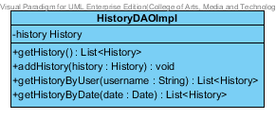

**Entities**

|  |  |  |  |
| --- | --- | --- | --- |
| **ID** | **NAME** | **DESCRIPTION** | **REMARK** |
| 1 | history | This is an object to hold history’s information. | **TYPE :** History |

**Method**

|  |  |  |  |
| --- | --- | --- | --- |
| **ID** | **NAME** | **DESCRIPTION** | **REMARK** |
| 1 | getHistory() | This method uses for getting a history. | **Return Type :** List<History> |
| 2 | addHistory() | This method uses for adding a history into a database. | **Return Type :** void  **Parameters :** history |
| 3 | getHistoryByName() | This method uses for getting a history list by using user’s name from database. | **Return Type :** List<History>  **Parameters :** username |
| 4 | getHistoryByDate() | This method uses for getting a history list by using date from database. | **Return Type :** List<History>  **Parameters :** date |

**4.5.3 MD-24: HistoryService**

**Class Name: HistoryService**

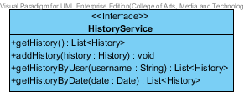

**Method**

|  |  |  |  |
| --- | --- | --- | --- |
| **ID** | **NAME** | **DESCRIPTION** | **REMARK** |
| 1 | getHistory() | This method uses for getting a history. | **Return Type :** List<History> |
| 2 | addHistory() | This method uses for adding a history into a database. | **Return Type :** void  **Parameters :** history |
| 3 | getHistoryByName() | This method uses for getting a history list by using user’s name from database. | **Return Type :** List<History>  **Parameters :** username |
| 4 | getHistoryByDate() | This method uses for getting a history list by using date from database. | **Return Type :** List<History>  **Parameters :** date |

**4.5.4 MD-25: HistoryServiceImpl**

**Class Name: HistoryServiceImpl**

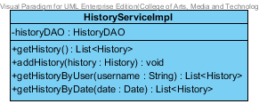

**Entities**

|  |  |  |  |
| --- | --- | --- | --- |
| **ID** | **NAME** | **DESCRIPTION** | **REMARK** |
| 1 | historyDAO | This is an object to hold HistoryDAO Class. | **TYPE :** HistoryDAO |

**Method**

|  |  |  |  |
| --- | --- | --- | --- |
| **ID** | **NAME** | **DESCRIPTION** | **REMARK** |
| 1 | getHistory() | This method uses for getting a history. | **Return Type :** List<History> |
| 2 | addHistory() | This method uses for adding a history into a database. | **Return Type :** void  **Parameters :** history |
| 3 | getHistoryByName() | This method uses for getting a history list by using user’s name from database. | **Return Type :** List<History>  **Parameters :** username |
| 4 | getHistoryByDate() | This method uses for getting a history list by using date from database. | **Return Type :** List<History>  **Parameters :** date |

**4.5.5 MD-26: HistoryController**

**Class Name: HistoryController**

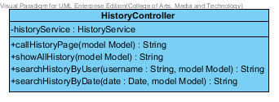

**Entities**

|  |  |  |  |
| --- | --- | --- | --- |
| **ID** | **NAME** | **DESCRIPTION** | **REMARK** |
| 1 | historyService | This is an object to hold History Service Class. | **TYPE :** HistoryService |

**Method**

|  |  |  |  |
| --- | --- | --- | --- |
| **ID** | **NAME** | **DESCRIPTION** | **REMARK** |
| 1 | callHistoryPage() | This method uses for connecting with History Page. | **Return Type :** String  **Parameters :** model |
| 2 | showAllHistory() | This method uses for showing all history list into History Page. | **Return Type :** String  **Parameters :** model |
| 3 | searchHistoryByUser() | This method uses for searching a history list by using user’s name from database. | **Return Type :** String  **Parameters :** name, model |
| 4 | searchHistoryByDate() | This method uses for searching a product by using date from database. | **Return Type :** String  **Parameters :** date, model |